**Homework 2**

**Instructions:** Do as many of the problems as you like, but make sure to complete at least **three**. Then the whole class will create a solution jointly (write below, or create a separate file; either is OK). One problem can have multiple solutions, so if your solution is different than the one already posted and you’d like to share yours with others, feel free to add yours. Make sure to separate different solutions to minimize confusion.

1. Show that if *a* and *b* divide *M* and [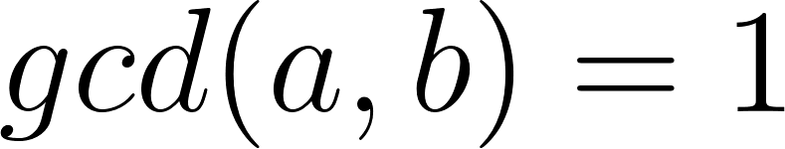](https://www.codecogs.com/eqnedit.php?latex=gcd(a%2Cb)%3D1#0), then [](https://www.codecogs.com/eqnedit.php?latex=a%5Ccdot%20b%20%7C%20M#0).
2. a. Prove that [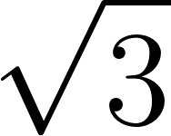](https://www.codecogs.com/eqnedit.php?latex=%5Csqrt%7B3%7D#0) is irrational.  
   b. You likely also saw that [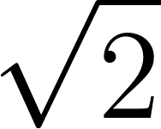](https://www.codecogs.com/eqnedit.php?latex=%5Csqrt%7B2%7D#0) is irrational in MTH 210. So, it feels like we can make a general statement. Come up with at least two different generalizations of the statement “[](https://www.codecogs.com/eqnedit.php?latex=%5Csqrt%7B2%7D#0) is irrational.” No need to write full proofs, but give some good reasonings for why the generalizations would be true.
3. Show that [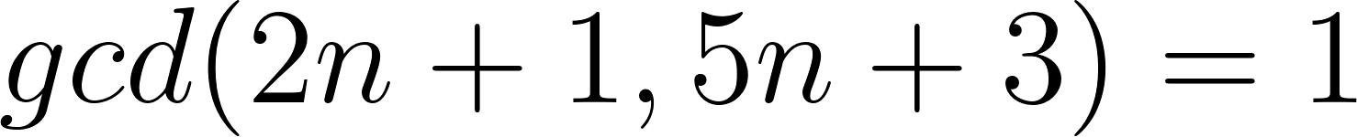](https://www.codecogs.com/eqnedit.php?latex=gcd(2n%2B1%2C5n%2B3)%3D1#0) for every *n*.
4. Show that if [](https://www.codecogs.com/eqnedit.php?latex=gcd(a%2Cb)%3D1#0), then [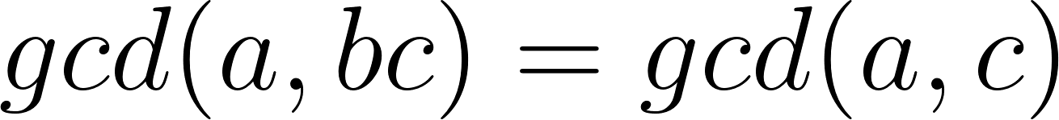](https://www.codecogs.com/eqnedit.php?latex=gcd(a%2Cbc)%3Dgcd(a%2Cc)#0).
5. Prove that if *M* is a multiple of *a* and *b*, then [](https://www.codecogs.com/eqnedit.php?latex=lcm(a%2Cb)%7CM#0). (Hint: One way to do this uses Division algorithm and contradiction. Another way uses the relationship between lcm and gcd, and Euclid’s lemma. There are possibly other ways too.)
6. (For those who have completed MTH 350) Look up the definitions of a prime element in a commutative ring, and an irreducible element in an integral domain. Since these words are different, the terms should not imply each other. Figure out in which cases one implies the other. Briefly summarize.
7. Write a code to find lcm of any two given positive integers. Then use lcm to find the gcd of the two integers.